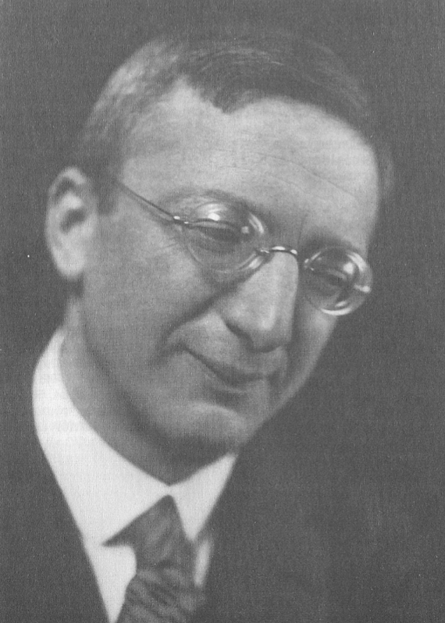**Döblin, (Bruno) Alfred (1878-1957)**

Alfred Döblin’s contributions to modern literature consist primarily of his montage style, epic narrative structures and critical eye toward contemporary culture. His masterpiece *Berlin Alexanderplatz. Die Geschichte vom Franz Biberkopf* (*Berlin Alexanderplatz. The Story of Franz Biberkopf*) brought international acclaim and is often credited as the first German-language city novel. He was Jewish and thus fled the Nazi regime, settling in Hollywood for a time. He returned to Germany as a French Cultural Officer; however, he found Germany unwilling to cope with the recent past. Feeling out of place in Germany, he emigrated again in 1953 to France, and died in 1957.

**Timeline of Life**

**1878 1888 1900-1905 1924 1933 1936**

| | | | | |

born in Stettin Moves to Berlin Studies medicine in Travels to Poland, Flees Nazi Germany, French

with mother, siblings Berlin and Freiburg religious awakening citizenship

**1941 1941-1945 1945 1953 1957**

| | | | |

Conversion to In Hollywood, Return to Second emigration Death in hospital in Germany,

Christianity often unemployed Germany to Paris burial in France

**Timeline of Works Published During Lifetime**

**1906 1913 1915 1920 1924 1925**

| | | | | |

*Lydia und Mäxchen Die Ermordung Die Drei Sprünge Wallenstein Die beiden Freundinnen Reise in Polen*

*einer Butterblume des Wang-Lun und ihren Giftmord*

**1929 1934 1937 1939 1946**

| | | | |

*Berlin Alexanderplatz Babylonische Reise ins Land ohne Tod Bürger und Soldaten Der Nürnberger Lehrprozess*

*Die Geschichte vom Wanderung**Der Oberst und der Dichter*

*Franz Biberkopf*

**1946-51 1956**

| |

*Das goldene Tor Hamlet. Oder die lange*

*Nacht nimmt ein Ende*

Döblin was born the fourth of five children in Szcecin (modern-day Poland). His father abandoned the family when Döblin was still young, motivating his mother to relocate to Berlin in 1888. He grew up in the working-class neighbourhoods and studied medicine. His first publication, *Lydia und Mäxchen* (1906), parodistically and self-reflexively deals with Döblin’s role as author, but found little readership. He married Erna Reiss in 1912, with whom he had four sons. He published a collection of short stories *Die Ermordung einer Butterblume* (*The Murder of a Buttercup*) in 1913. The title story features a salesman who absent-mindedly knocks the flower off a buttercup during a walk. His resulting fear of nature’s revenge for this misdeed (often read as a symbolic rape) escalates to neurotic levels. Döblin here combined his literary talents with his medical training, which included training in psychiatry.

In 1914 he signed with the prestigious S. Fischer publishing house. During the 1910s and 1920s, he developed his epic style, eschewing 19th century novelistic convention by relinquishing a focus on psychology to focus on larger events and social forces. He often set his novels in exotic locales and other historical periods to allow a certain alienation from and criticism of the present. This is demonstrated in his *Die drei Sprünge des Wang-Lung* (*The Three Leaps of Wang-Lung* (1915)*,* set in 18th century China, which deals with violence and pacificism on individual and state levels. His *Wallenstein* (1920) ran against the grain of German historical novels by critiquing, not praising, the Thirty Years’ War. The novel treated violence as a series of interconnected events with little to no sense to bind them, and focused on events and masses as opposed to individuals. These and other exotic works by Döblin – such as *Babylonische Wanderungen* (1934) or his *Amazonas* (1937-48) trilogy – often combine fantasy with Döblin’s almost scientific style, and often include or were inspired by books on history, maps and other nonfiction sources.

Pogroms against Jews in 1923 sparked an interest in Döblin’s Jewish heritage, culminating in a 1924 trip to Poland to visit Jewish communities there. The result was the travelogue *Reise in Polen* (*Journey to Poland*) (1925), in which Döblin charts his discovery of Jewish tradition, with which he was largely unfamiliar. (His interest in religion persisted throughout his life, and he converted to Catholicism in 1941.)

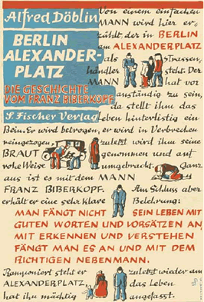

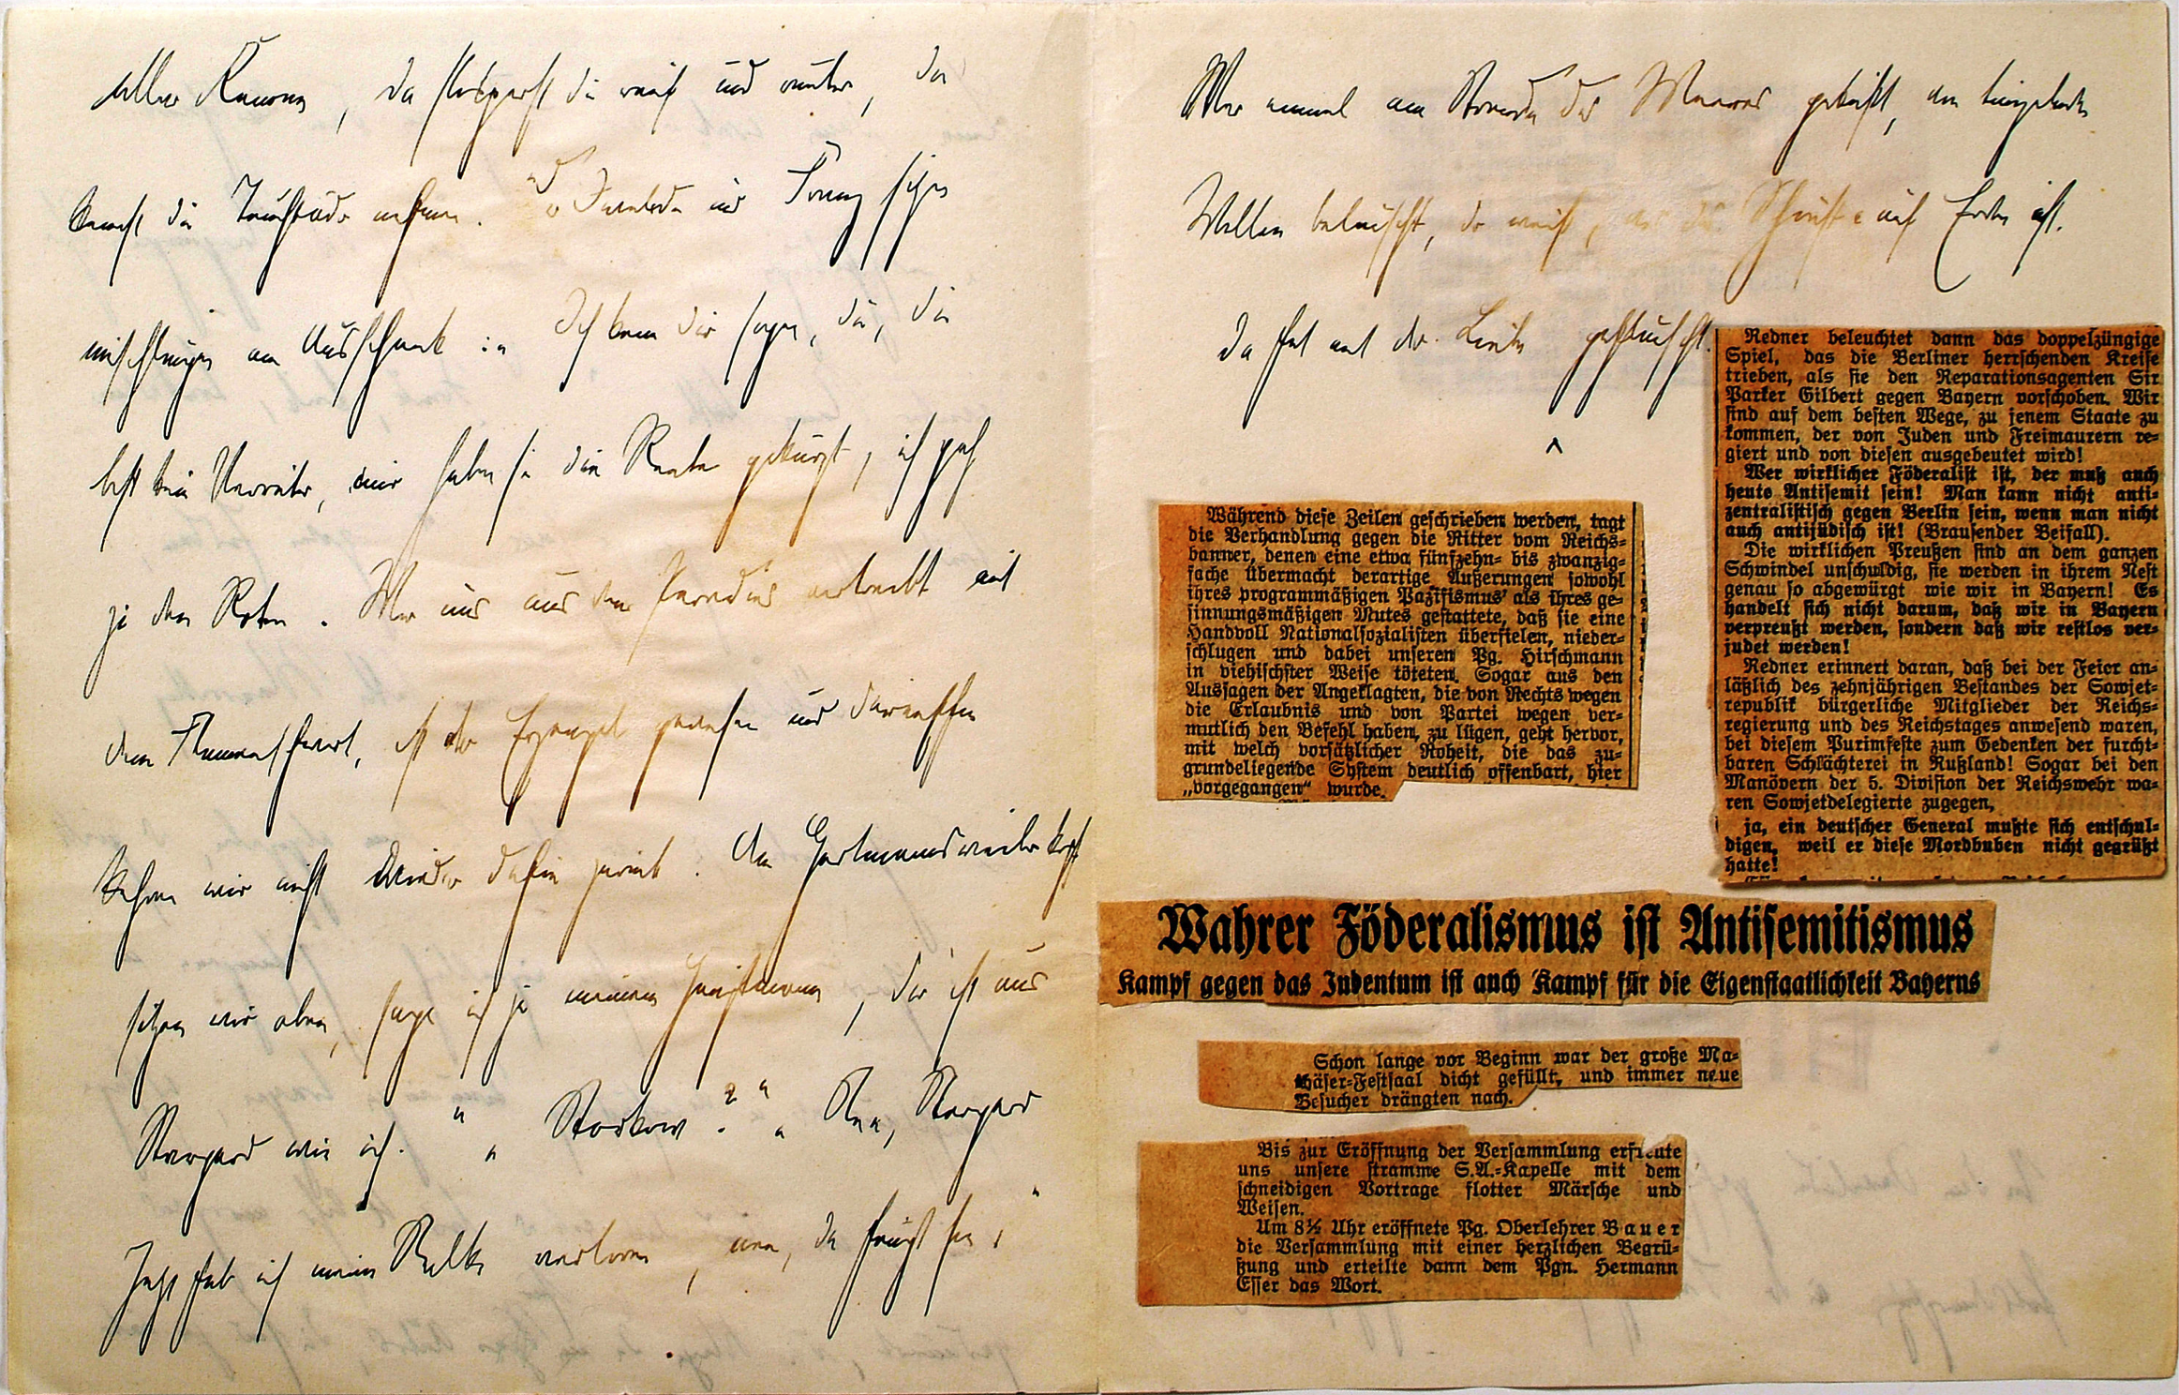*Berlin Alexanderplatz* (1929) brought immediate international acclaim and was a popular hit for Döblin, whose dense work is often challenging for readers. The novel renders Franz Biberkopf impotent against the economic and social hardships of Berlin. Including newspaper articles, postcards and other texts as well as a plurivocal narrative perspective, Döblin’s montage makes the novel a cacophony sights, sounds and narrators. It is a masterpiece of Döblin’s epic style (an attempt to recapture oral narrative structures unbounded by the limitations of print) and a modernist classic frequently compared to James Joyce’s *Ulysses*. Often associated with New Objectivity, Döblin uses documentary sources to inform his highly realistic portrayal of social problems in this and other works such as *Die beiden Freundinnen und ihr Giftmord* (1924), a novelization based on court documents about a highly publicized double murder. Work on radio and film versions of *Berlin Alexanderplatz* occupied Döblin for two years, yet the political climate exerted tremendous force on these projects. The radioplay was cancelled last minute due to pressure from right wing groups, and the 1931 film was sanitized of its political content.

*Berlin Alexanderplatz*, 1st Ed.

Hitler’s appointment as chancellor in 1933 forced Döblin and his family to flee Germany. Settling first in Paris, Döblin became a French citizen in 1936. In 1940 Döblin arrived in Los Angeles, where he secured a job as a writer for Metro-Goldwyn-Mayer, but found little success. His one-year contract with MGM resulted only in uncredited contributions to *Mrs. Miniver* and *Random Harvest* (both 1942).

*Berlin Alexanderplatz* manuscript with inserted newspaper clippings.

His tetralogy *November 1918* about the failed beginnings of the Weimar Republic occupied much of his time during exile, but he was only able to publish the first installment before the war. The rest of the volumes were published after the war. The tetralogy narrates the early and turbulent years of the Weimar Republic, and was again marked by Döblin’s signature multimedial style in which he freely mixed documents from the era with personal memories.

Despite his declining health in the 1950s, it was his great desire to see his war novel *Hamlet, oder die lange Nacht nimmt ein Ende* (*Tales of a Long Night)* (1956) published before his death. The novel tells the story of a returned soldier as he and his family struggle to heal his psychological wounds. A generational split is apparent, with the parents displaying guilt for being responsible for creating the war in which their son fought. The novel was published eight months before his death.

In 1953, feeling there was ‘no air to breathe’ in Germany, Döblin and his wife returned to Paris. He passed away in 1957 in hospital in Emmendingen, Germany. Reflecting his persistent feeling of dislocation in Germany and the German literary scene even in death, he was buried in Housseras, France.

Döblin’s literary works, letters, autobiographical writings and other works have been collected and edited in *Ausgewählte Werke in Einzelbänden* (1961-2001), and include much of his non-literary output – speeches given and publications in periodicals, which often focus on aesthetic and theoretical explanations of Döblin’s style.

**References and Further Reading:**

Dollinger, Roland, Wulf Köpke and Heidi Thomann Tewarson. (2004) *A Companion to the Works of Alfred Döblin*. Rochester, NY: Camden House. (Comprehensive overview including a broad range of themes, genres and stylistic developments in Döblin’s works.)

Köpke, Wulf. (2003) *The Critical Reception of Alfred Döblin’s Major Novels.* Rochester, NY: Camden House. (Traces Döblin’s reception through the twentieth century. Especially focused on his impact on German literature, yet paradoxical lack of scholarly attention.)

**Key Biographies of Alfred Döblin:**  
Kort, Wolfgang. (1974) *Alfred Döblin*. New York: Twayne. (In English. Includes a concise biography and study of themes in Döblin’s works.)

Sander, Gabrielle. (2001) *Alfred Döblin*. Stuttgart: Reclam. (In German. Includes a lengthy biography and a comprehensive history, reception and analysis of Döblin’s writings.)

**Key Works**

* *Ausgewählte Werke in Einzelbänden* (1960—2007. Originally published by the Olten Verlag. In 2008 the project transferred to S. Fischer Verlag).

* *Die Ermordung einer Butterblume und andere Erzählungen* (1913)

* *Die drei Sprünge des Wang-Lun* (1915, translated as *The Three Leaps of Wang-Lun,* 1991)

*\* Berlin Alexanderplatz. Die Geschichte vom Franz Biberkopf* (1929, translated as *Berlin Alexanderplatz. The Story of Franz Biberkopf*, 1931)

* *Hamlet. Oder die lange Nacht nimmt ein Ende* (1956, translated as *Tales of a Long Night*, 1984)